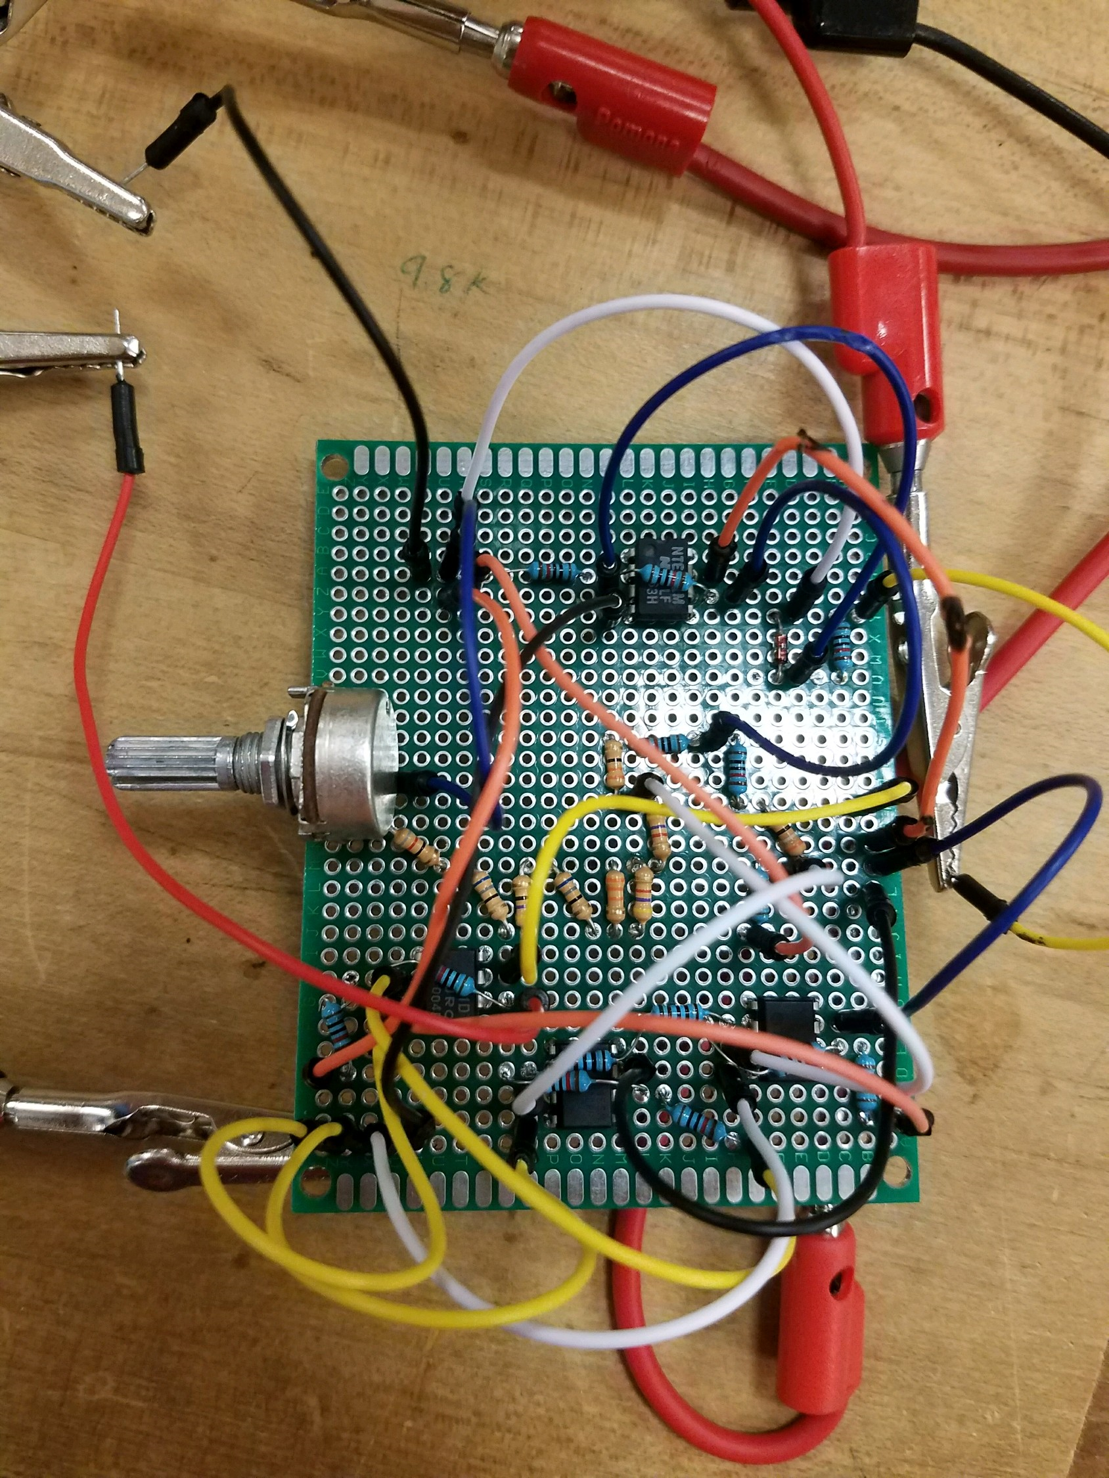

Figure 9: Proto board designed and soldered

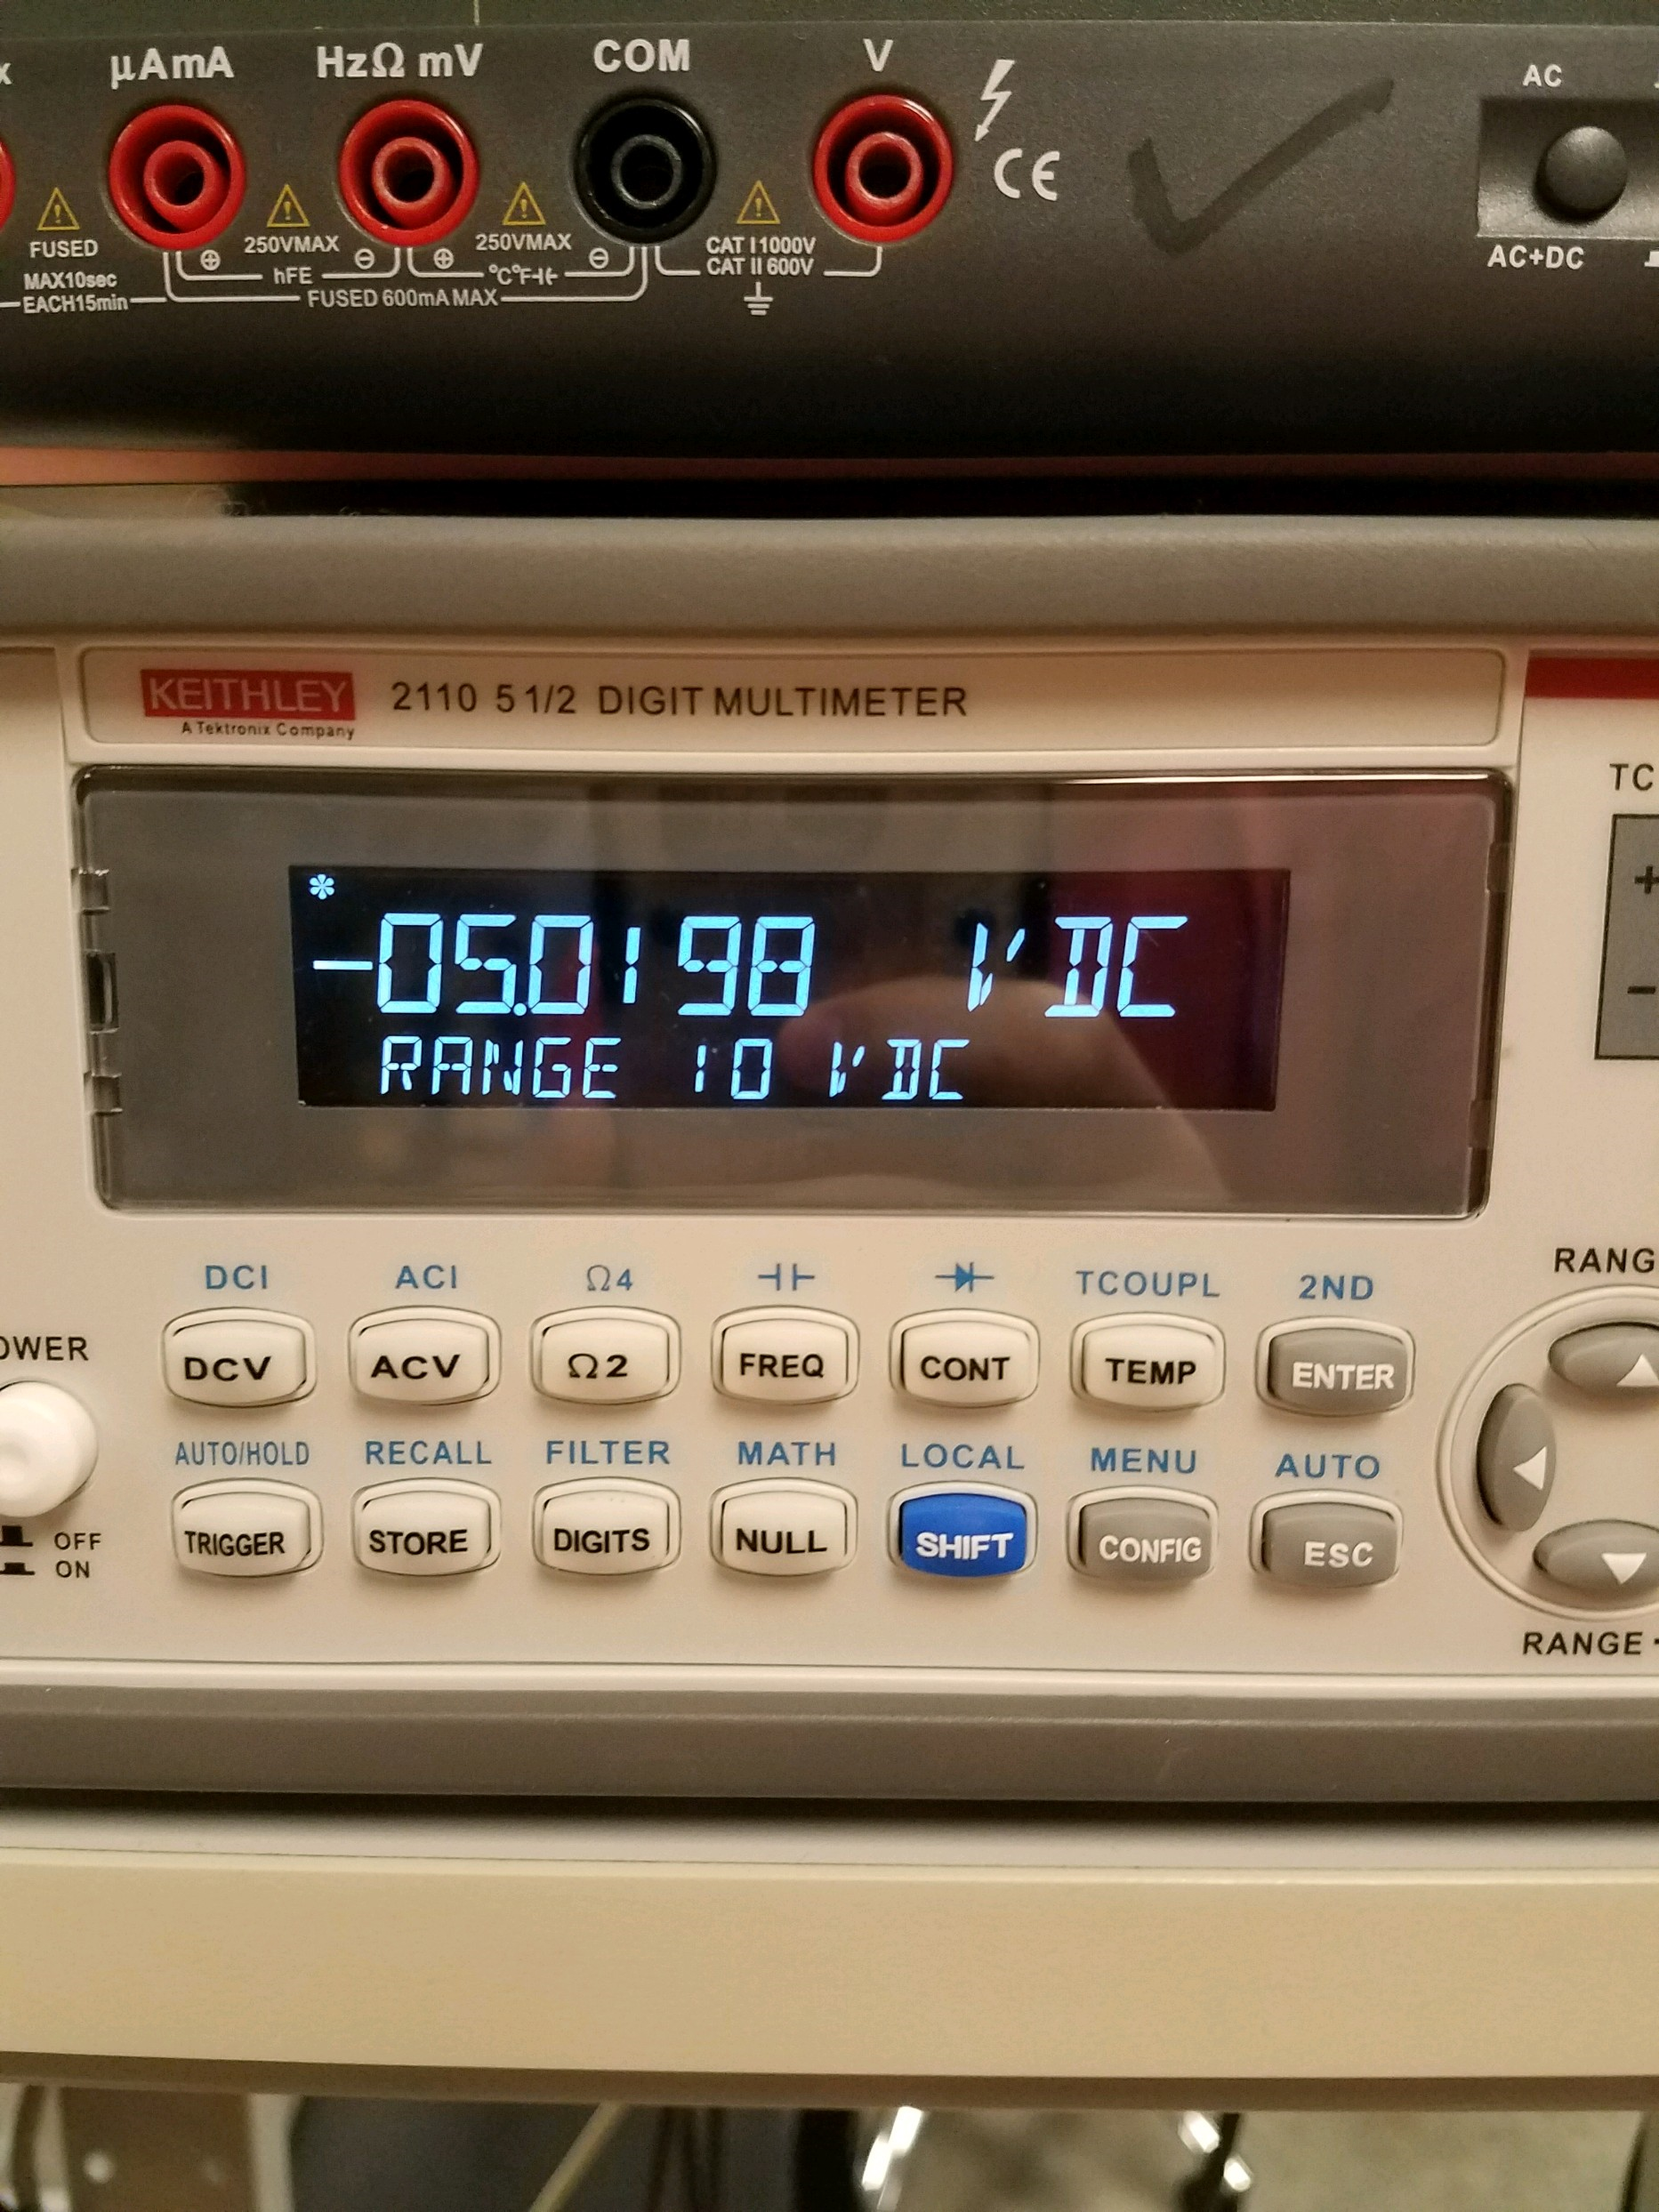

Figure 10: Negative output of proto board

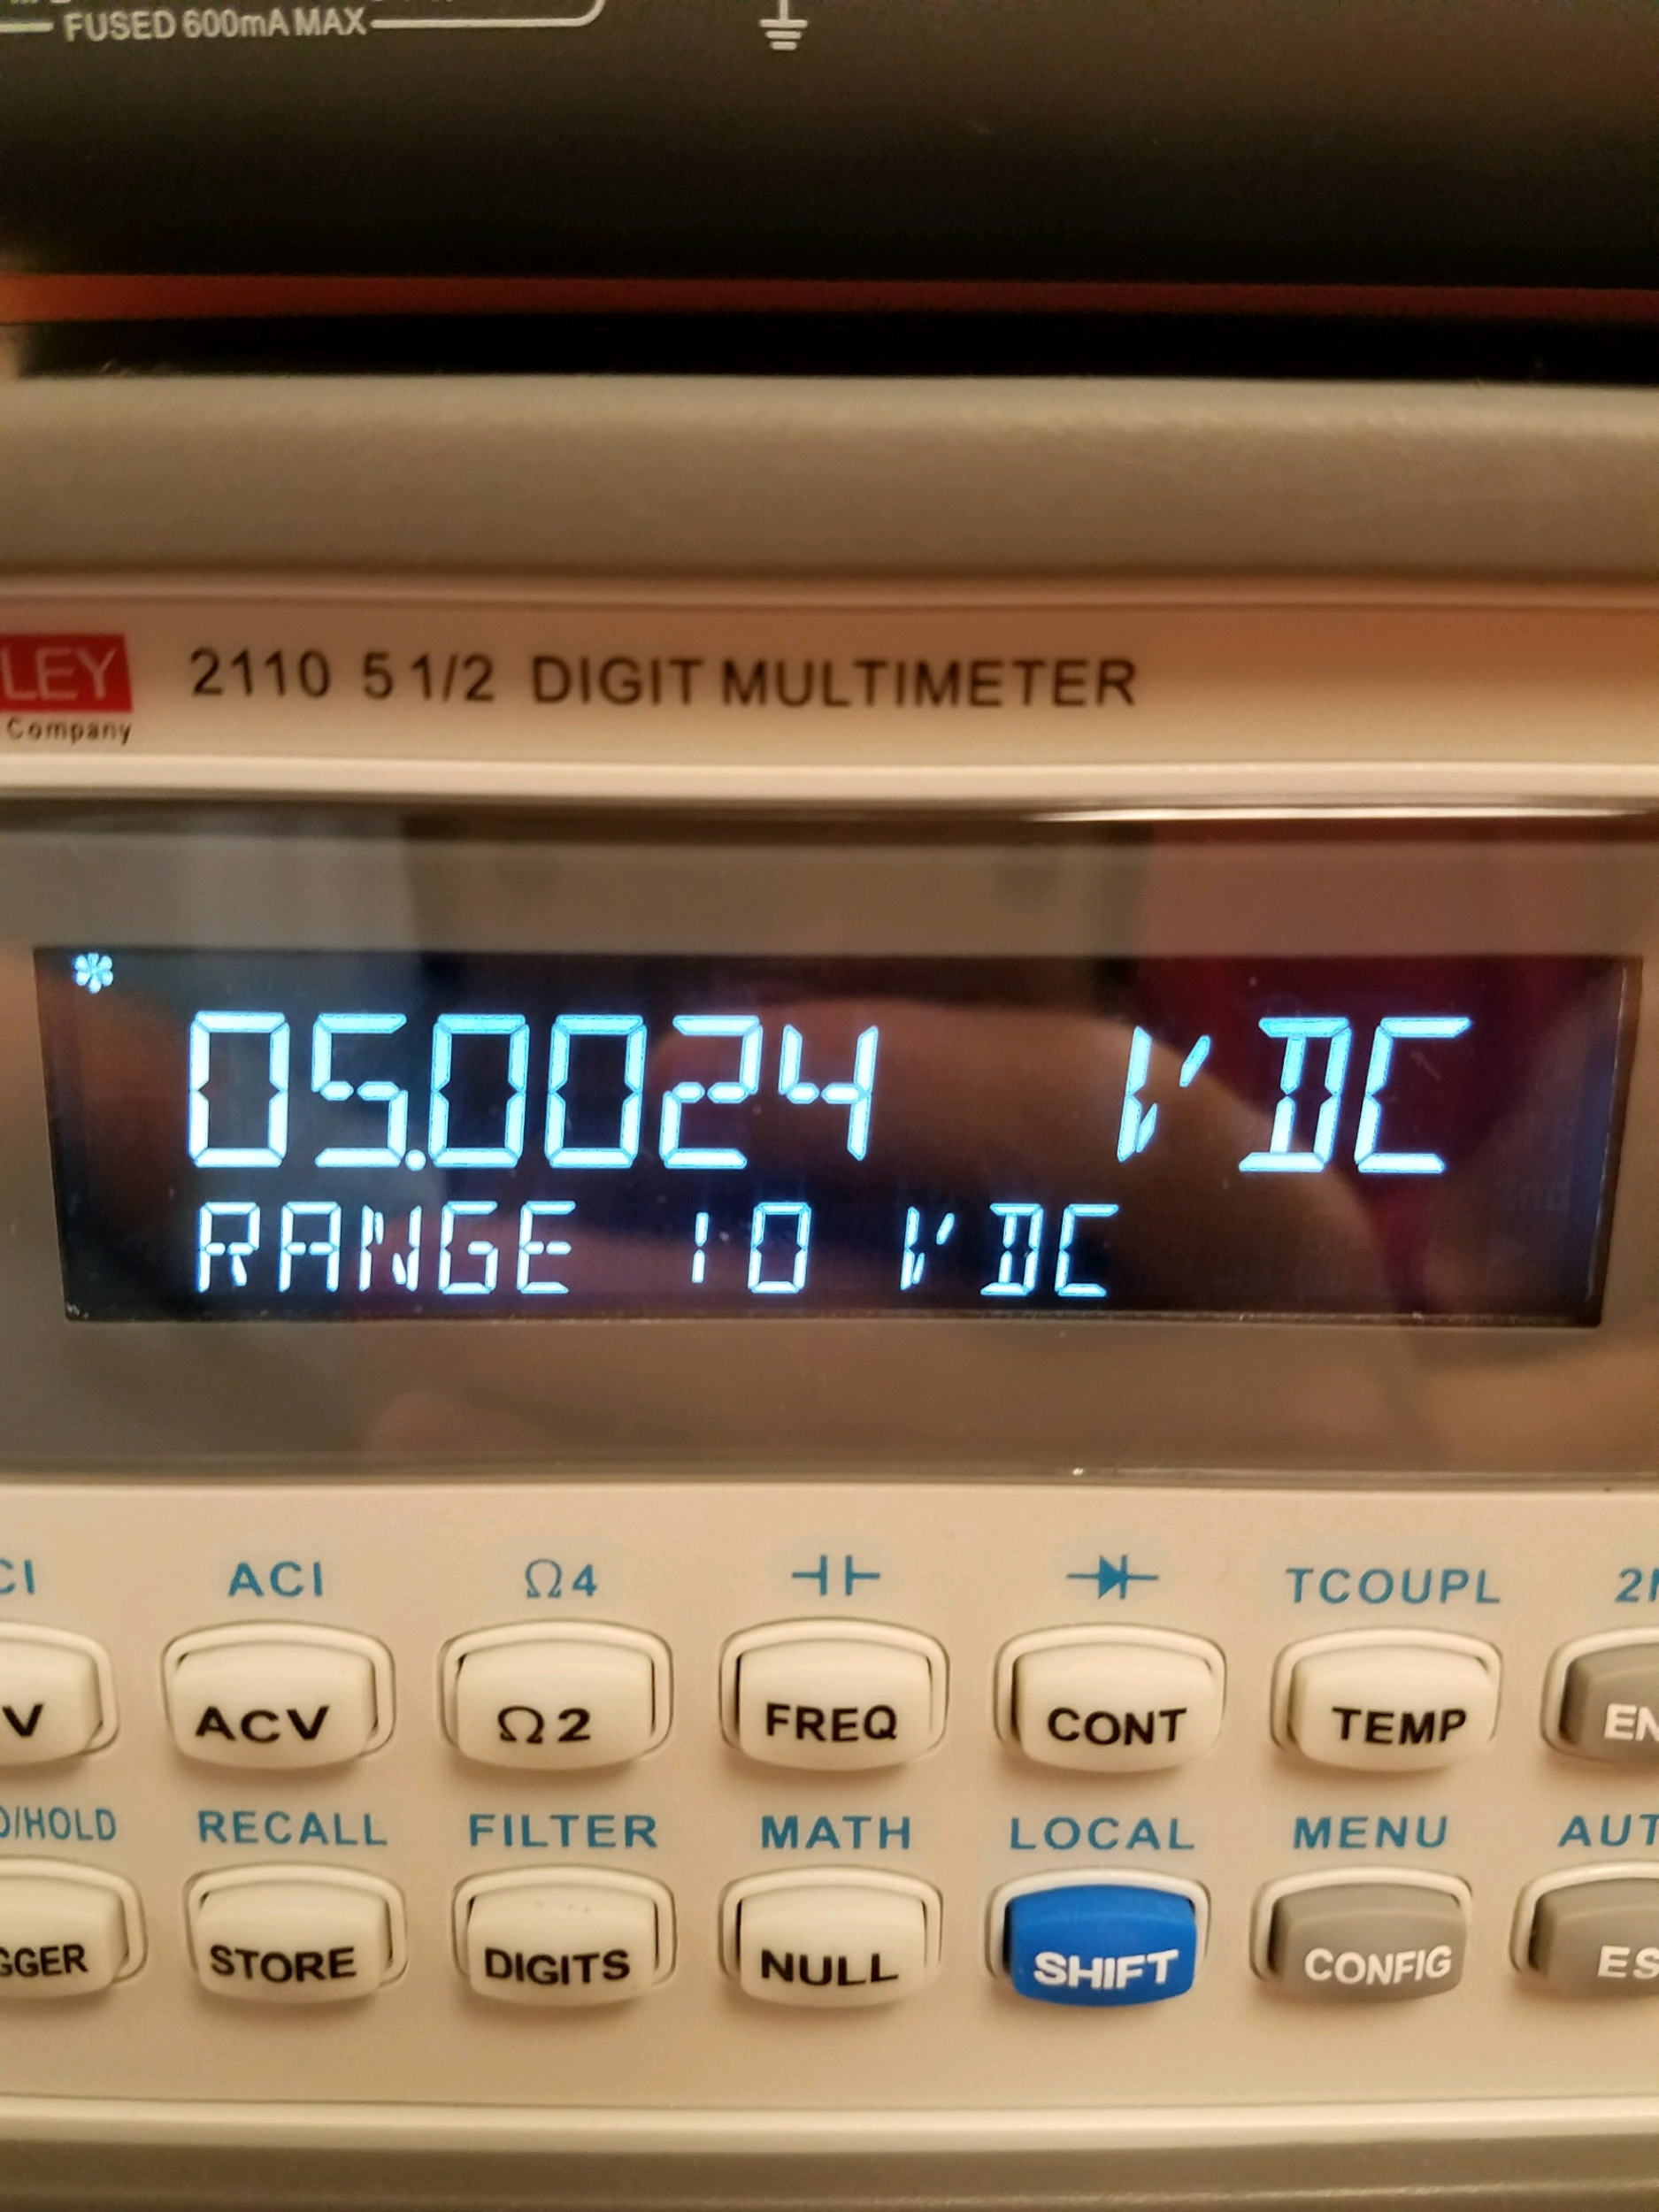

Figure 11: Positive output of proto board

Altium CIRCUITMAKER 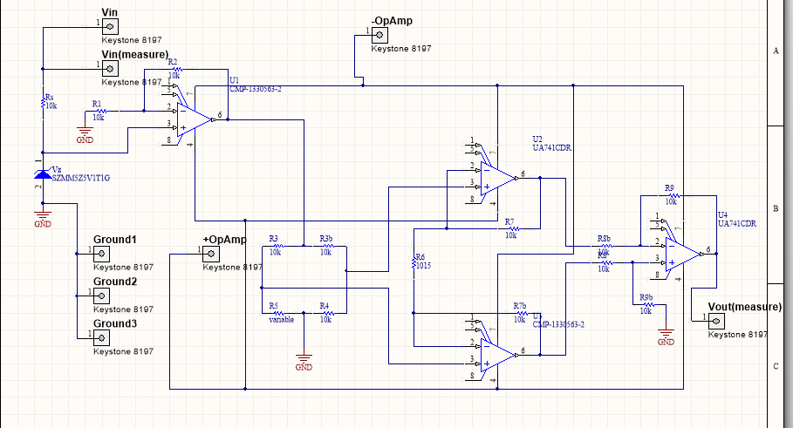

Above is the instrumentation op amp circuit that was created using Altium CIRCUITMAKER. This schematic closely resembles the one made in Pspice, however the wires connecting the Op Amps to their negative and positive power can be seen. The blocks with circles within them are screw terminals. These screw terminals allow wires to be plugged in for the purpose of powering the circuit, grounding components, or taking voltage measurements.

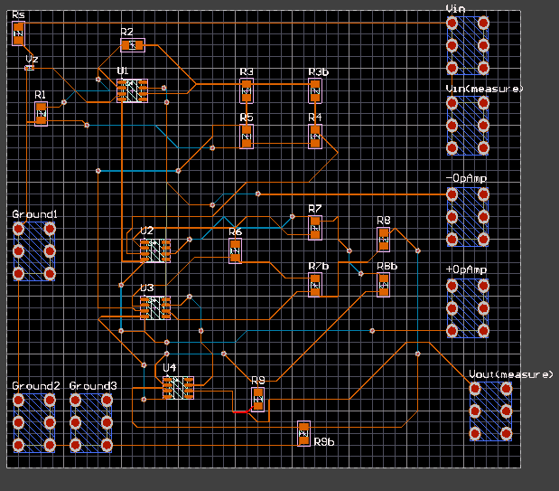

Above is the 2d image of the PCB board that was created using CIRCUITMAKER. The parts were placed in position manually, but the software tells you what parts need to be connected. The orange wire represents copper that is layed on top of the board to connect components. The blue wire indicates where the copper travels under the board so that it does not collide with other routes.

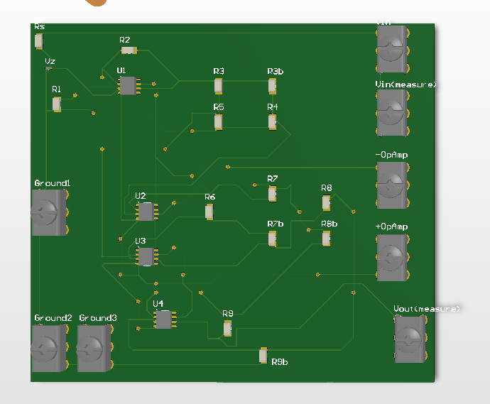

Above is the 3d image of the final pcb board. The diode, resistors, op amps, and screw terminals can be seen rising of the board’s surface. The copper wire routes can also be seen. The circular points indicate where the wire tunnels to the underside of the board.

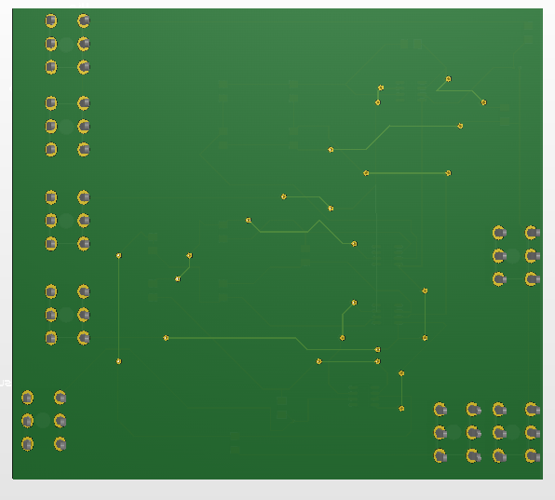

Above is a 3d view of the underside of the pcb board. The pins of the screw terminals that would be soldered can be visibly seen sticking out of the board. There are no pins sticking out where the op amps, zener diode, and resistors are because of the type of components chosen; although these are not the type of components most often seen, they can still be ordered for use in the pcb board if it were bought. The copper wires that tunnel to the underside of the board can also be visibly seen here.

Discussion

The resistor Rs merely affects the current across the zener diode. Varying Vs will affect the point at which the zener diode turns on and can slightly vary the zener diode voltage Vz because the diode’s internal resistance produces additional voltage based on current supplied. Using a large value for Rs will decrease the current entering the diode which will cause the voltage Vz to be more stable for fluctuations of Vs, however increasing the resistance can reduce the current to a point where the diode will not be on. The diodes used in the lab do not have ideal properties; if the diode is not supplied the current specified on the data sheet then it may be partially on rather than being completely off. The Vz measured in our circuit was around 4.7V when Vs=10V and Rs=10k, but the data sheet specified that zener diode voltage should be 5.1V. This was because the diode was only partially on due to lack of current. Although this did not cause our instrumentation op amp circuit to fail, we could have corrected this problem by reducing Rs to a resistance which would allow the specified minimum diode current to be reached. When the Zener diode is supplied enough current to turn on, the voltage entering the first op amp will be regulated by the diode. At this point, the voltage entering the op amp will be equal to Vz. Therefore the purpose of the diode is to regulate voltage entering the circuit to a steady DC value at points where the diode receives minimum current.

The values of the resistors in the bridge circuit must be carefully balanced. For example, if the left R3 value is even a couple of Ohms different than the right R3 value then the output voltage of the circuit will be drastically affected. Therefore, the resistor tolerances must be taken into account, an ohmmeter must be used to find the exact values, and then smaller resistor values must be added in series to achieve bridge resistances that are very similar. This is why small resistors like 33 Ohms and 39 Ohms were used in series with some of the resistors in the bridge.

R6 was another value that drastically affected the output voltage and needed to be very close to the actual value for the circuit to operate correctly but this was likely because the other resistors were equivalent in our design R7=R8=R9=10K so most of these resistor terms cancelled out in the equations since they were in the numerator and denominators. So, R6 very heavily affected the output voltage of the circuit of our design because it was one of the few terms that did not cancel out, and it was the only resistor we specified to have a unique value.

The transducer R5 was made up of a 2K Ohm potentiometer and a series of resistor values that were added carefully to produce close to 9.0252K Ohms when the potentiometer is completely off and close to 11.0308K Ohms when the potentiometer is completely on. 9.0252K Ohms is equal to our actual value of R4 minus 10%, and at this resistance of R5, the output voltage of the circuit should be close to -5 volts. 11.0308K Ohms is equal to our actual value of R4 plus 10%, and at this resistance of R5, the output voltage of the circuit should be close to +5 volts. Our breadboard and protoboard circuits yielded results that were at maximum only 23mV away from -5V or +5V. These results were very desirable relative to those seen by other groups.

When putting together the breadboard circuit, the method that was found most useful for troubleshooting the circuit was to first check that all the resistances in the circuit matched those that were in Pspice, especially R6 and those in the Wheatstone bridge. After each resistor value was checked and corrected by adding resistors in series or swapping out resistors, the circuit was double checked for corrected wiring. Next, the voltage exiting each piece of the circuit was tested from start to end. By checking the zener diode voltage, output voltage of the first op amp, output voltages of the bridge circuit, and then output voltages of the other three op amps in order, the circuit can be easily corrected. Using this method, our group was able to discover that our first op amp was broken. After replacing it, our breadboard circuit’s output was very close to the results that were desired. The only setback for our protoboard circuit was that one node seemed to be fully soldered however the solder did not fully contact each part.

Conclusion

The output of our circuit was almost exactly +/- 5.0 V. Accounting for non-ideal op amps and resistor values to be off by a thousandth of a decimal, the results slightly varied from the Pspice results. In conclusion when the transducer is paired with the correct ratio of resistor values, the voltage may be amplified until the saturation value of the operational amplifier is reached and +/- 5.0V is achieved.

References

Sedra, Adel/ Smith, Kenneth (2015) Microelectronic Circuit Seventh Edition. Oxford University Press.